



London, Queen Mary University
Centre Handbook
2026

Contents

Contents 2
Summary 3
The Centre 3
Location 4
Airport Transfers: 4
Campus Map……………………………………………………………………………………………………………………………..5
Local Amenities 6
Accommodation 8
Room Allocation 8
Housekeeping 8
Key Loss 8
Deposits 8
Meals 9
Meal times 9
Sample Menu………………………………………………………………………………………………………………………………………………………10
Technology 11
Security 11
Safety 11
Teaching 12
Placement tests Error! Bookmark not defined.
Programme 13
A typical day for students 13
Queen Mary, London Sample Programme - Summer 2025 15
Facilities 16
Evening entertainment 16

Thank you very much for your interest in our Queen Mary University Centre. We hope you find everything you need in the following pages but if you have any questions or specific requests then please get in touch with us at Head Office on +44 (0)1244 577995.

The contents of this handbook are updated regularly. The latest version will be sent before your arrival.

We look forward to a successful summer 2026 at Queen Mary University, London!

Summary


Amazing city centre location

University

Ensuite accommodation
Short Transfers

The Centre

London is truly one of the world’s great cities. Every year it welcomes thousands of international students who want to visit Europe’s most popular attractions.

Queen Mary University of London is one of the UK’s leading research-focused higher education institutions and a member of the elite “Russell Group” of British universities. It is the perfect base from which juniors can explore the capital. A closed campus in Zone 2, Mile End is just 7 minutes from Bank Station in central London. We have up to 380 beds available at Queen Mary’s University which contain a mix of single en-suite and single standard bedrooms. In this centre, we accept students travelling in groups from 11- 17 years old.


Location

Queen Mary University of London
Mile End Road
London E1 4NS
+44 (0) 20 7882 5555

Queen Mary University, Mile End Campus is situated in zone 2, just a 5 minutes’ walk to Mile End Tube Station.

Airport Transfers:
London Gatwick: 1 hour 15 minutes
London Heathrow: 1 hour 15 minutes
London Stansted: 45 minutes
London City: 20 minutes
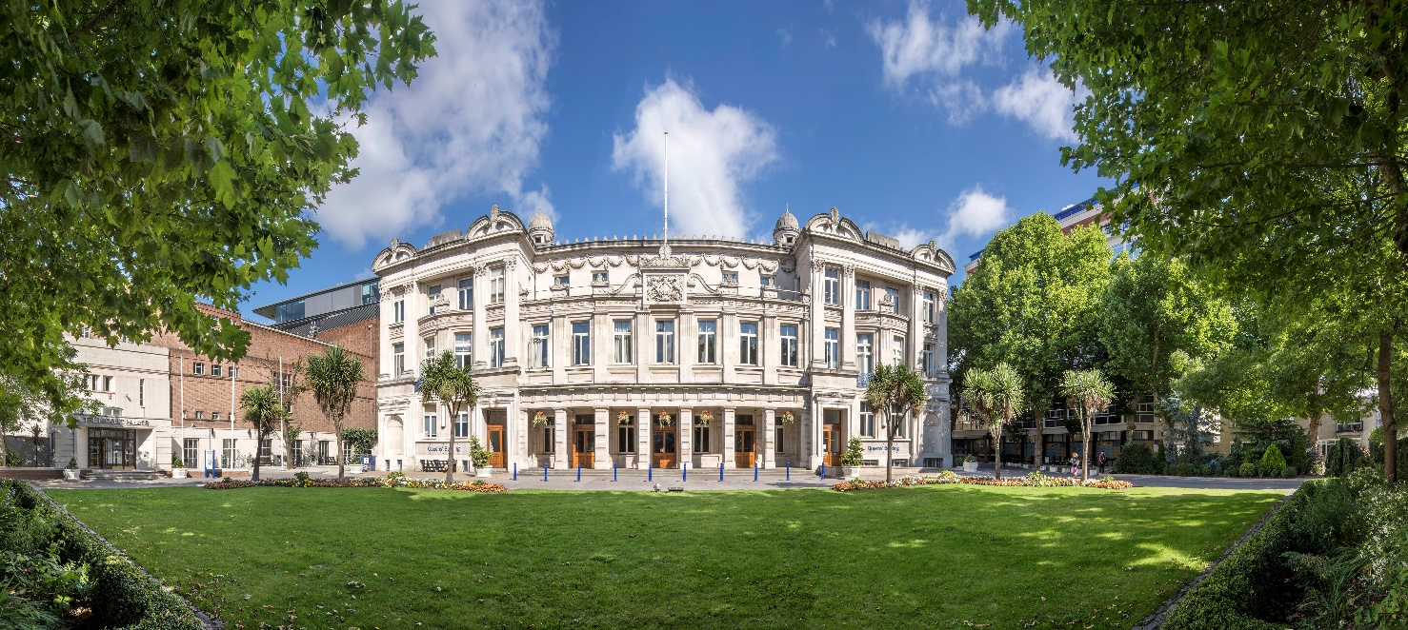

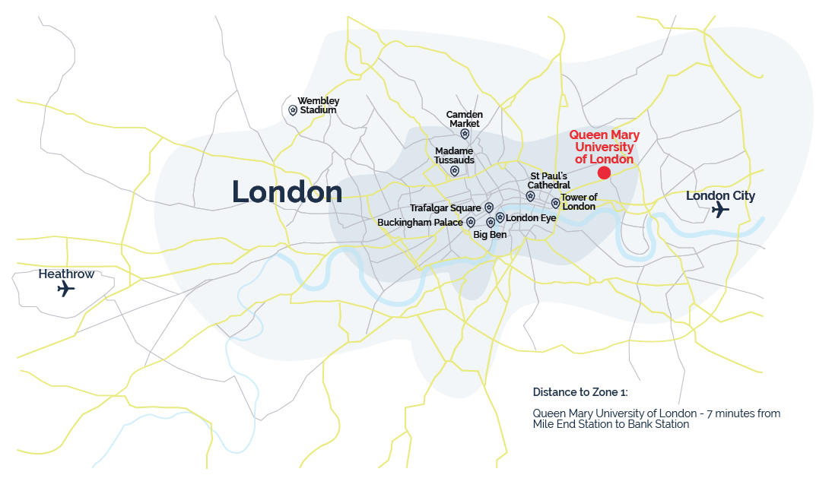
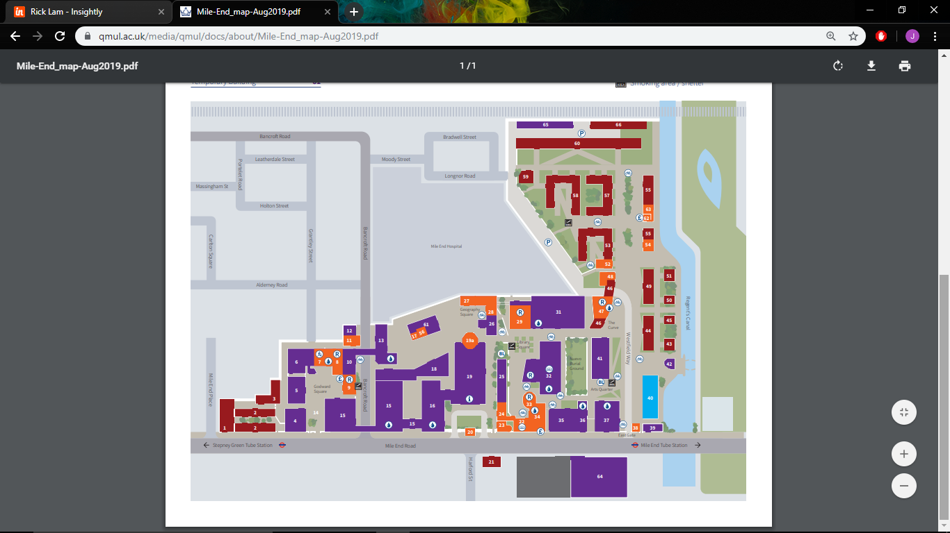
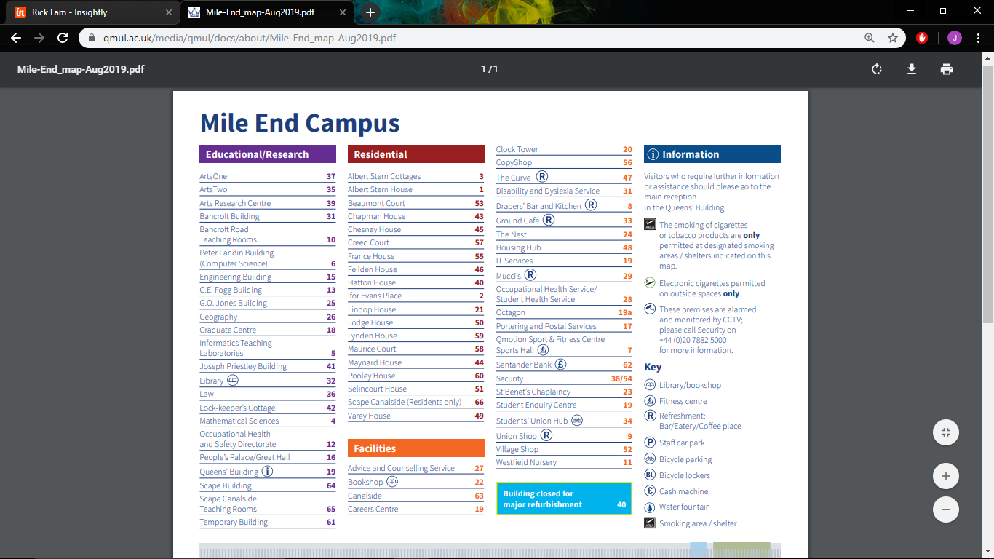

Local Amenities

Post Office
Address: 13 Burdett Rd, Mile End, London E3 4TU (0.3 miles / 5 minutes’ walk)

Supermarket
Sainsbury’s Local
Address: 430 Mile End Rd, London E1 4PE (400 ft / 1-minute walk)

ATM
Sainsbury’s Bank
Address: 430 Mile End Rd, London E1 4PE (400 ft / 1-minute walk)

Chemist
Medichem Pharmacy
Address: 100 White Horse Lane, Stepney, London, E1 4LR (0.2 miles / 5-minute walk)
N.B. – After visiting the chemist, if a student is ill and requires a doctor, a Group Leader and a UKLC staff member will take the student to the Soho Walk in centre (35 minute journey). The student will be required to fill out a temporary patient form and will be seen on the same day.

Hospital
Mile End Hospital
Address: Bancroft Rd, Bethnal Green, London E1 4DG (0.2 miles / 3 minutes’ walk)
Telephone: 020 7377 7000
N.B – A student will be taken to the hospital by a Group Leader and a UKLC staff member in emergency circumstances i.e. severely unwell, injuries requiring x-ray. The student will be required to fill out a temporary patient form and will wait in Accident and Emergency.

Dentist
Mile End Dental Practice
Address: 227 Mile End Rd, Stepney, London E1 4AA
Telephone: 020 7790 6066

Bus Stops
Turn out of the college and they are approximately 25 metres away. There are frequent buses that run to the City of London.

Train Stations
Mile End Tube Station
Address: Mile End Rd, Mile End, London E3 4DH
Mile End Tube Station is on the Central, District and Hammersmith & City line.
Walking distance to Mile End Tube Station: 0.3 miles (5 minutes’ walk)

Taxi Companies
Addison Lee: 020 7407 9000

Coffee Shops
Ground Café – On the University Campus

The Curve – On the University Campus

Starbucks
Serves a variety of light bites and main meals with relaxed surroundings.
Address: 389 Mile End Rd, Mile End, London E3 4QS Walking distance from : 0.3 miles (5 minutes’ walk)

Restaurants
Verdi’s
Pop into Verdi’s for high end Italian at this modern neighbourhood restaurant that’s become a bit of a local gem. Fresh Italian pastas are the knockout here with the pizzas not far behind. The menu changes regularly, but keeps everything affordable. Great for a mid-week low key meal.
Address: Mile End Rd, Stepney, London E1 4AA. Walking distance from Queen Mary University: 0.2 miles (2 minutes’ walk)

Palmer’s
Palmers is a bit of an institution. This family-run restaurant focuses on British cuisine with most of the ingredients from Billingsgate and Spitalfields markets to keep things proper East End. There’s no jellied eels in sight though, more asparagus and Stilton quiche or decent juicy steaks, all served in a really welcoming atmosphere.
Addres: 238 Roman Rd, Bethnal Green, London E2 0RY. Walking distance from Queen Mary University: 0.6 miles (12 minutes’ walk)

Accommodation

The University has up to 380 beds available which contain a mix of single en-suite and single standard bedrooms. Each corridor has a kitchen on every floor that can be accessed, but the students will not be allowed to use any appliances, only the fridges. We use different house [e.g. Feilden House, Beaumont, Creed, Maynard and many other]

Each house is made up of single rooms, and each flat has its own kitchen, where students will only be allowed to use the fridges. Most houses are ensuite, but a few are standard shared bathroom [bathroom ratio of 1:6].

Room Allocation
We divide the students up according to their age, gender and group where possible. The Group Leader will be in charge of assigning the rooms. Group leaders will stay in the same house as their students. Room allocation is normally done on arrival. If you would like any further information on this, please contact us.

Housekeeping
Rooms will be cleaned once a week, including bathroom and kitchen facilities. Rooms to be checked every other day including emptying bins and bathroom check. There will be one linen/ bedding change once per week and one towel change per week. Towels will be included. Student laundry will be done by Group Leaders via app operated washing machines and tumble dryers located in Frances House.

Key Loss
All students and group leaders will receive their own key card and key for the duration of their stay. If any key is lost or not returned before departure, there will be a fee ranging between £90 to £120 for a replacement.

Deposits
We will ask each student for a deposit of €25/£25 on arrival. We will check their rooms before they arrive and before they leave, returning the money if everything is in order. If there is damage to the houses and nobody admits fault, we will ask everyone in the house to share the cost.
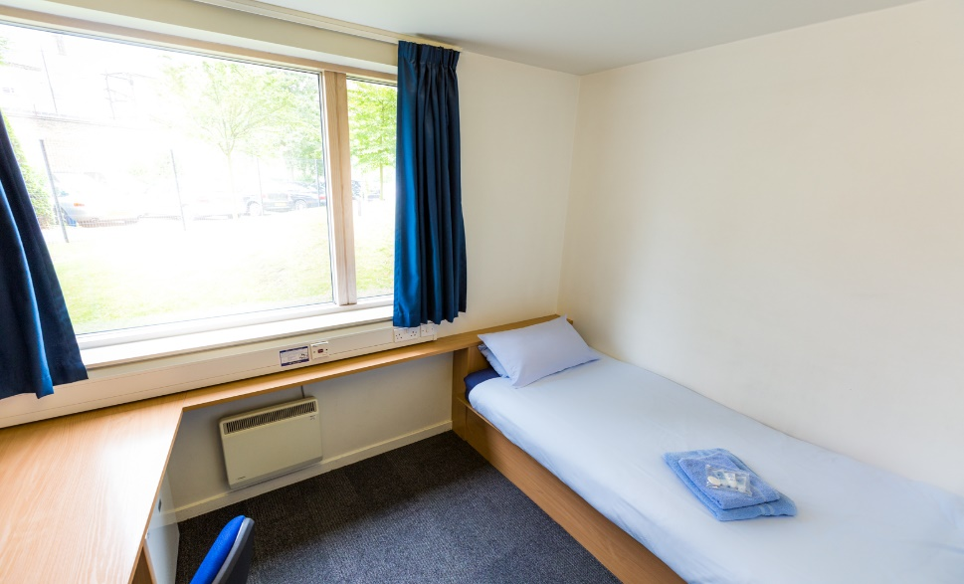

Meals

When the students are on campus, they will eat their meals in the dining hall on site. When they are out on full day excursions, they will be provided with packed lunches.
Cooked breakfast is supplied once a week.

Meal times*
Breakfast: 08:00 – 09:00
Lunch: 12:45 – 13:45
(Lunch on Thursdays will be a BBQ cooked on campus)
Dinner: 18:45 - 20:00

If we are aware in advance, we can advise the catering staff of any dietary requirements or allergies and the canteen staff can cater to these.

*Mealtimes are subject to change – different meal times [depending on zig zag] will be explained during the Welcome Talk]
 | Monday | Tuesday | Wednesday | Thursday | Friday | Saturday | Sunday
Breakfast | Croissants  Toast, Cereal, Yoghurt  Butter and Jams | Croissants  Toast, Cereal, Yoghurt  Butter and Jams | Croissants  Toast, Cereal, Yoghurt  Butter and Jams | Croissants  Toast, Cereal, Yoghurt  Butter and Jams | Croissants  Toast, Cereal, Yoghurt  Butter and Jams | Croissants  Toast, Cereal, Yoghurt  Butter and Jams | Croissants  Toast, Cereal, Yoghurt  Butter and Jams  Full English Breakfast
Lunch  *(V) Vegetarian option available | Beef Lasagne  Vegetable  Lasagne (v)  New Potatoes  A Selection of Fresh Vegetables  Jacket Potatoes with a variety of Fillings  Salad Selection  Fresh Fruit  Soup of the Day  Bread Roll with Olive Oil & Butter  Pasta & Sauce of the Day  Grilled Cajun Chicken Baguette  Hummus & Roasted Vegetable Baguette (v) | Coq au Vin  Risotto with Charred Leeks (v)  Rice  A Selection of Fresh Vegetables  Jacket Potatoes with a variety of Fillings  Salad Selection  Fresh Fruit  Soup of the Day  Bread Roll with Olive Oil & Butter  Pasta & Sauce of the Day  Chicken or Ham &  Margarita or Mediterranean Veg Pizza (v) | Steak & Guinness Sausages  Quorn Sausages (v)  Mash Potatoes & Gravy  A Selection of Fresh Vegetables  Jacket Potatoes with a variety of Fillings  Salad Selection  Fresh Fruit  Soup of the Day  Bread Roll with Olive Oil & Butter  Pasta & Sauce of the Day  Tuna & Sweetcorn Baguette  Feta Cheese Baguette (v) | BBQ Burgers and Sausages with meat and vegetarian options.  Fries and Salad Selection. | Battered or Grilled Haddock with Fennel  Mushroom Carbonara (v)  A Selection of Fresh Vegetables  Jacket Potatoes with a variety of Fillings  Salad Selection  Fresh Fruit  Soup of the Day  Bread Roll with Olive Oil & Butter  Pasta & Sauce of the Day  Southern Fried Chicken Pieces & fries  Pepper & Bean Burritos (v) | Sweet and Sour Chicken  Chilli & Pepper Frittata (v)  A Selection of Fresh Vegetables  Jacket Potatoes with a variety of Fillings  Salad Selection  Fresh Fruit  Soup of the Day  Bread Roll with Olive Oil & Butter  Pasta & Sauce of the Day  BLT Baguette or Beef Baguette  Spiced Falafel and Spinach Wrap (v) | Cheddar Roast (v)  Roast Potatoes  A Selection of Fresh Vegetables  Jacket Potatoes with a variety of Fillings  Salad Selection  Fresh Fruit  Soup of the Day  Bread Roll with Olive Oil & Butter  Pasta & Sauce of the Day  Tuna or Cheese & Bacon Panini  Cheese & Tomato or Soft Cheese & Pepper Panini (v)
Dinner  *(V) Vegetarian option available | Chilli Baked Bassa  Polenta & Lentil Cakes (v)  Quarter Pounder Beefburger  Spicy Bean Burger (v)  Fries, Lemon Cous Cous  A Selection of Fresh Vegetables  Salad Selection  Soup of the Day  Bread Roll with Olive Oil & Butter  Pasta & Sauce of the Day | Beef & Mushroom Pie  Butternut Squash Pie (v)  Chicken Nuggets  Vegetable Spring Rolls (v)  Mash Potato, Rice  A Selection of Fresh Vegetables  Salad Selection  Soup of the Day  Bread Roll with Olive Oil & Butter  Pasta & Sauce of the Day | Chicken Tagine  Bean and Squash Tagine (v)  Fish Goujons  Vegetable Nuggets (v)  Fries, Cous Cous  A Selection of Fresh Vegetables  Salad Selection  Soup of the Day  Bread Roll with Olive Oil & Butter  Pasta & Sauce of the Day | Roast Chicken  Tortellini Ricotta (v)  Hot Dogs  Vegetarian Hot Dogs (v)  Roast Potatoes, Tomato Pasta  A Selection of Fresh Vegetables  Salad Selection  Soup of the Day  Bread Roll with Olive Oil & Butter  Pasta & Sauce of the Day | Chilli Con Carne  Vegetarian Sausage Jambalaya (v)  Pasties  Cheese and Onion Pasties (v)  Fries, Rice  A Selection of Fresh Vegetables  Salad Selection  Soup of the Day  Bread Roll with Olive Oil & Butter  Pasta & Sauce of the Day | Thai Fish Cakes  Broccoli and Cheddar Quiche (v)  Pepperoni or Cajun Chicken Pizza  Margarita or Mediterranean Veg Pizza (v)  Wedges, Noodles  A Selection of Fresh Vegetables  Salad Selection  Soup of the Day  Bread Roll with Olive Oil & Butter  Pasta & Sauce of the Day | Chicken Tikka  Chick Pea & Lentil Dahl (v)  Chicken Burger  Spicy Bean Burger (v)  Fries, Rice  A Selection of Fresh Vegetables  Salad Selection  Soup of the Day  Bread Roll with Olive Oil & Butter  Pasta & Sauce of the Day
Pudding | Pudding | Mousse | Ice Cream | Sponge & Custard | Ice Cream | Caramel Heaven | Ice Cream

Queen Mary’s University - Sample Menu

Technology

Wi-fi is available in all the houses and parts of the campus and is password protected. We normally only give this password out to Group Leaders / adults due to it being a university campus and limited on firewall security. It is at the Group Leader’s discretion whether they give these details to their students.
There is computer access on campus, and you will have access to this on a timetabled basis.
There are no public phones on site. The nearest is on Mile End Road, approximately 500 yards from the residence.

Security

There is extensive CCTV coverage on campus and duty security officers as well as overnight security officers including 24 hour security.

Emergency contacts: Each student will be given a wristband when they arrive, and this will have the following emergency telephone number printed on it: 00 44 1244 567695. If you need to contact the centre in the event of an emergency please call this number and follow the options for the relevant centre, this will then put you through to the person on duty.

Certain basic guidelines are common to all centres and students. Students should:
- Never walk away alone!
- Never leave the residence without permission in the evening!
- Always make sure they have understood when and where the meeting point is whilst
out on excursions!
- Always wear their identification lanyard and their UKLC wristband! *
*students found not wearing their lanyard or wristband will be fined £1

Safety

- Remember that there is a 24-hour emergency telephone number on the wristband (0044 1244 567695) and that the number for the emergency services (Ambulance/Police/Fire) in England is 999, or the single emergency number for the EU including the UK is 112 or you can call 101 to report a crime where you do not need an emergency response
- The police are there to help and protect and can be asked for assistance!
- Never respond to someone if you feel threatened, simply walk away!
- Always give your money to the UKLC management team to put in the safe and never to carry large amounts of cash around!
- Be careful crossing the road. Remember that in the UK we drive on the left!
- If you are ill or need a doctor, tell a member of UKLC staff immediately!
- Keep all windows closed when not in your bedrooms!
Insurance and valuables
Although all houses will be accessed via swipe and/or key cards, it is suggested that students try to avoid bringing very expensive items with them. If they are bringing valuables with them, it essential that they have sufficient insurance to cover any loss of damage as neither the centre nor the company can be held responsible if anything goes missing. The Centre Manager will have access to a safe if it is required.

Teaching

We know how important it is for each individual student to find their own path in language learning. We use a wide range of methods to engage and stimulate our students. This is why we have created a curriculum based on the students’ age, level and needs, structured into four different programmes:
FUN (ages 8-10)
Engaging lessons that offer a wide range of materials and activities specific for our young learners, making games into lessons and lessons into games. Available in levels A1-B1.

CONNECTION (ages 10-13)
Dynamic lessons covering a variety of topics and media, designed to engage students using tools native to the fast-paced world they are growing up in. Available in levels A1-C1.

ACTION (ages 13-16)
Lessons tailored for learners stepping into their teenage years. This programme focuses on activating students’ knowledge and competencies to balance developing a personal voice while contributing effectively to a team. Available in levels A1-C1.

PURPOSE (ages 16-18)

Lessons tailored for our students approaching adulthood, designed to kickstart their lives not only as maturing youths but also as forward-thinking global citizens. Available in levels A1-C2.

The Connection, Action, and Purpose programmes consist of three different lessons a day:

FOCUS ON LANGUAGE

These lessons aim to empower our students’ linguistic awareness and capabilities by working on all language skills (reading, writing, listening, speaking) and systems (grammar, phonology, lexis, discourse), as well as using materials relevant to exam preparation (KET, PET, FCE, CAE, TOEFL, IELTS, GESE).

FOCUS ON LEADERSHIP

This programme is designed to equip students with essential 21st-century skills, focusing on leadership development, communication and teamwork. Students build the confidence and competencies needed to grow into empowered young adults.

FOCUS ON CULTURE
These lessons combine CLIL and British culture, allowing students to use English to explore a range of disciplines, including art, literature, natural sciences, as well as the history and geography of the UK.

Placement tests
We offer classes at four levels, from elementary to advanced. Students take a placement test on their first day of classes to ensure they are placed at the correct level.

Once the tests have been marked, students won’t be told their score unless they specifically ask for it but will be placed into a class based on these results.

If students are not happy with their level, they can speak with the Course Director who will decide if it is necessary for the student to change levels.

We always try to split groups into different classes to mix nationalities, but this does depend on their levels and the numbers of students that we have on site.

We will provide all course materials including a journal and a pen.

Students are taught in class sizes up to 16.

Programme

All UKLC summer programmes include:

- 15 hours of English lessons
- Full board accommodation in residence
- Full programme of excursions and evening entertainment
- 1 free leader for 15 students
- Placement test on arrival and End of Course Certificate

A typical day for students

08:00 – 09:00 Breakfast

09:00 – 10:00 Lesson 1

10:00 – 10:15 Break

10:15 – 11:15 Lesson 2

11:15 – 11:30 Break

11:30 – 12:30 Lesson 3

12:30 – 13:30 Lunch

14:00 – 17:30 Excursion

18:30 – 19:30 Dinner

20:00 – 22:00 Evening Activities

22:00 Bedtime

This centre runs on a ‘zig-zag’, meaning the order of lessons and excursions will change after a week. See example below.

Queen Mary, London Sample Programme - Summer 2025

 |  | Morning |  | Afternoon | Evening
 | Monday | English Test |  | Tate Modern Gallery | Trashion Show
Week 1 | Tuesday | Lessons |  | The British Museum & Covent Garden | Message Disco or Conversation Club
 | Wednesday | Lessons |  | The National Gallery | Film Night
 | Thursday | Lessons |  | Notting Hill & Portobello | Red vs Blue
 | Friday | Lessons |  | The National Science Museum | Paparazzi or Conversation Club
 | Saturday | London – Buckingham Palace, Downing Street, House of Parliament, Big Ben & Madame Tussauds |  |  | Quiz Night
 | Sunday | Brighton Walking Tour with Royal Pavilion |  |  | Oscars or Conversation Club
 | Monday | National Portrait Gallery & Leicester Square | Lessons |  | Treasure Hunt
Week 2 | Tuesday | Natural History Museum |  | Lessons | Karaoke or Conversation Club
 | Wednesday | Greenwich with National Maritime Museum |  | Lessons | Mini Olympics
 | Thursday | London Museum Docklands |  | Lessons | Film Night
 | Friday | Knightsbridge, Hyde Park & Harrods |  | Lessons | Talent Show
 | Saturday | Camden Town, Market & Regent’s Canal |  |  | Leaving Disco
 | Sunday | Depart

Please note: This is a sample programme and may be subject to change. It may also be necessary to operate a zig zag programme of morning / afternoon lessons.

Facilities

- Recreational and social areas
- Lecture theatres
- There are no sports facilities on site

Evening entertainment

The UK Language Courses staff plan fantastic activities to make sure the students enjoy their evenings. For example: discos, quizzes, fashion shows, blind date, sports tournaments etc. We ask Group Leaders to encourage students to participate as much as possible and to communicate any special ideas or requests from students.

Here are a few brief descriptions of just some of our activities for students to join in on:

Around the World
Consists of a number of different stations based on activities from different countries. One staff member will be placed at each activity station. They will each represent a country and have to create an activity related to that country (for example: New Zealand – The Haka). Students will be divided into groups and given a time for each station. Students will visit each station.

Oscars Night
Involves students watching a number of scenes from selected films. They will have the chance to re-enact a famous selected scene. Creating their own script, which must be in English and costumes (out of various given equipment). Scenes will be shown on a big screen for everyone to watch. Awards will be given by UKLC staff for the best reproduction.

Speed Dating
Enables students from mixed nationalities to socialise and get to know each other whilst improving their spoken English. Students will have a short period of time to have a conversation on their interests, hobbies etc. Once the given time finishes they will move to another student and begin the same process again.

Talent Show
Gives students the opportunity to perform talents such as singing, dancing and acting in front of the whole centre! Sign-up sheets will be available in the centre a few days before the event. There will be judges who will score the performances and give positive feedback to each student who performs on the evening.

We look forward to welcoming you to Queen Mary, London in summer 2026!







